Name : Hisham Essam Abdelfatah Mohamed .

B.N: 1023
Date:7/6/2021
Topic: Artificial Intelligence

GitHub Link : https://hishamhagag10.github.io/ece001/

Application Brief:
I have chosen this topic to spotlight on one of the most technological trend these days known as AI (Artificial Intelligent).Therefore; I will focus on the History of A.I., the definition of artificial intelligence and its Pros and Cons and discusses some of the most common AI Algorithm and Models along with some application on of AI. Last but not least, the paper will display AI Design Models moreover; how is it related to Virtual Assistants such as "Siri".
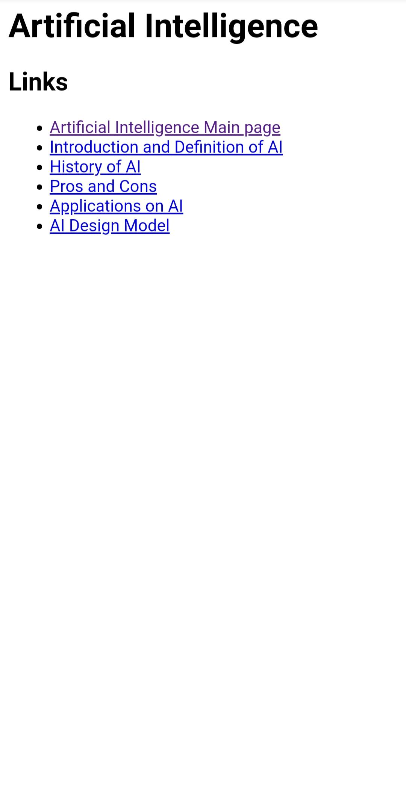
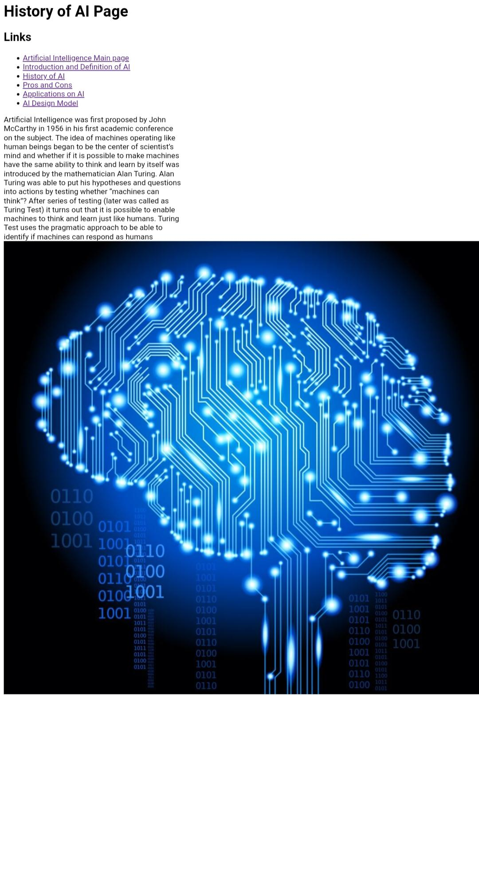
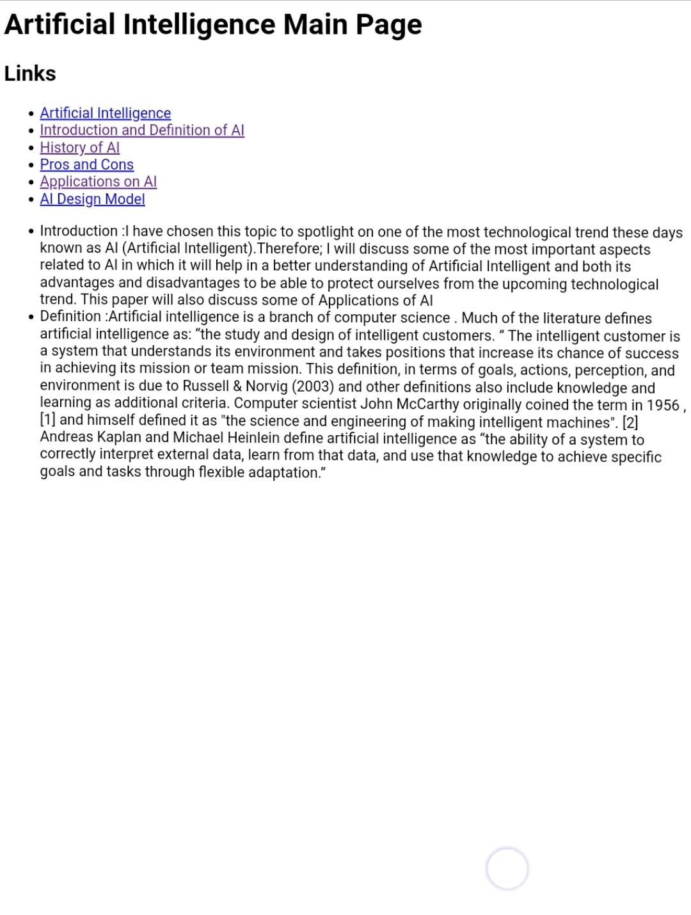
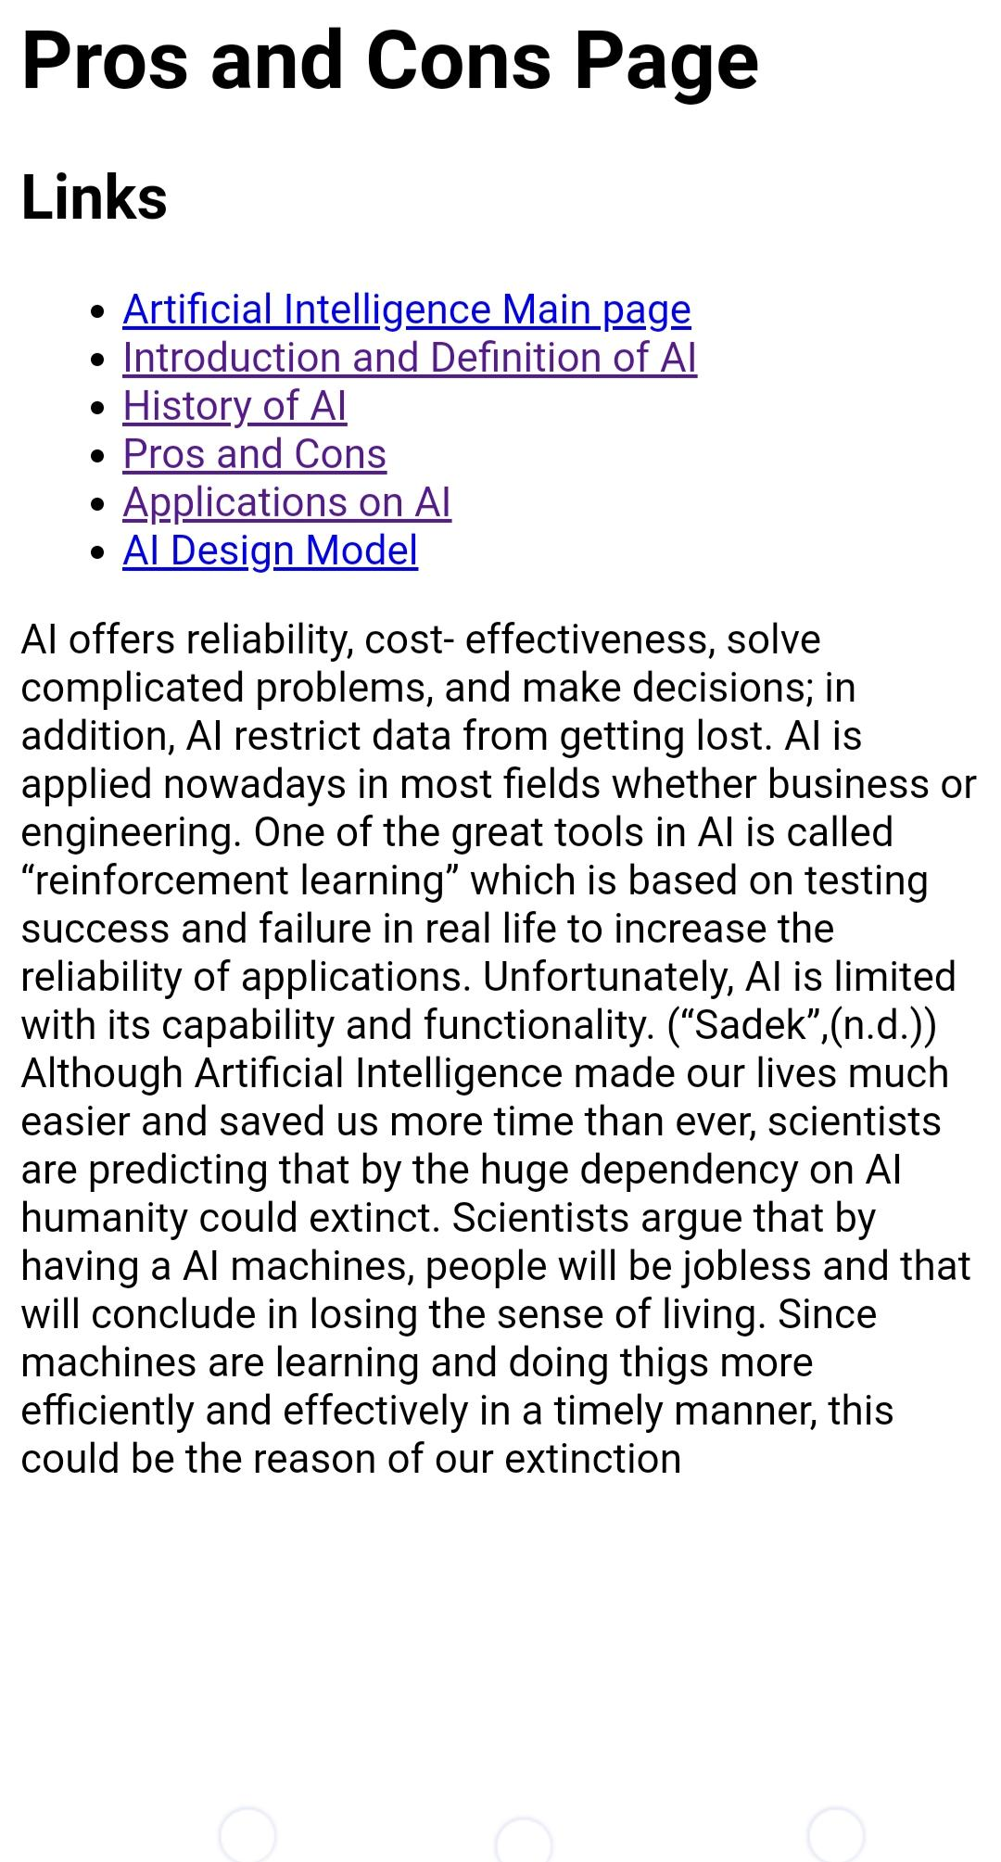
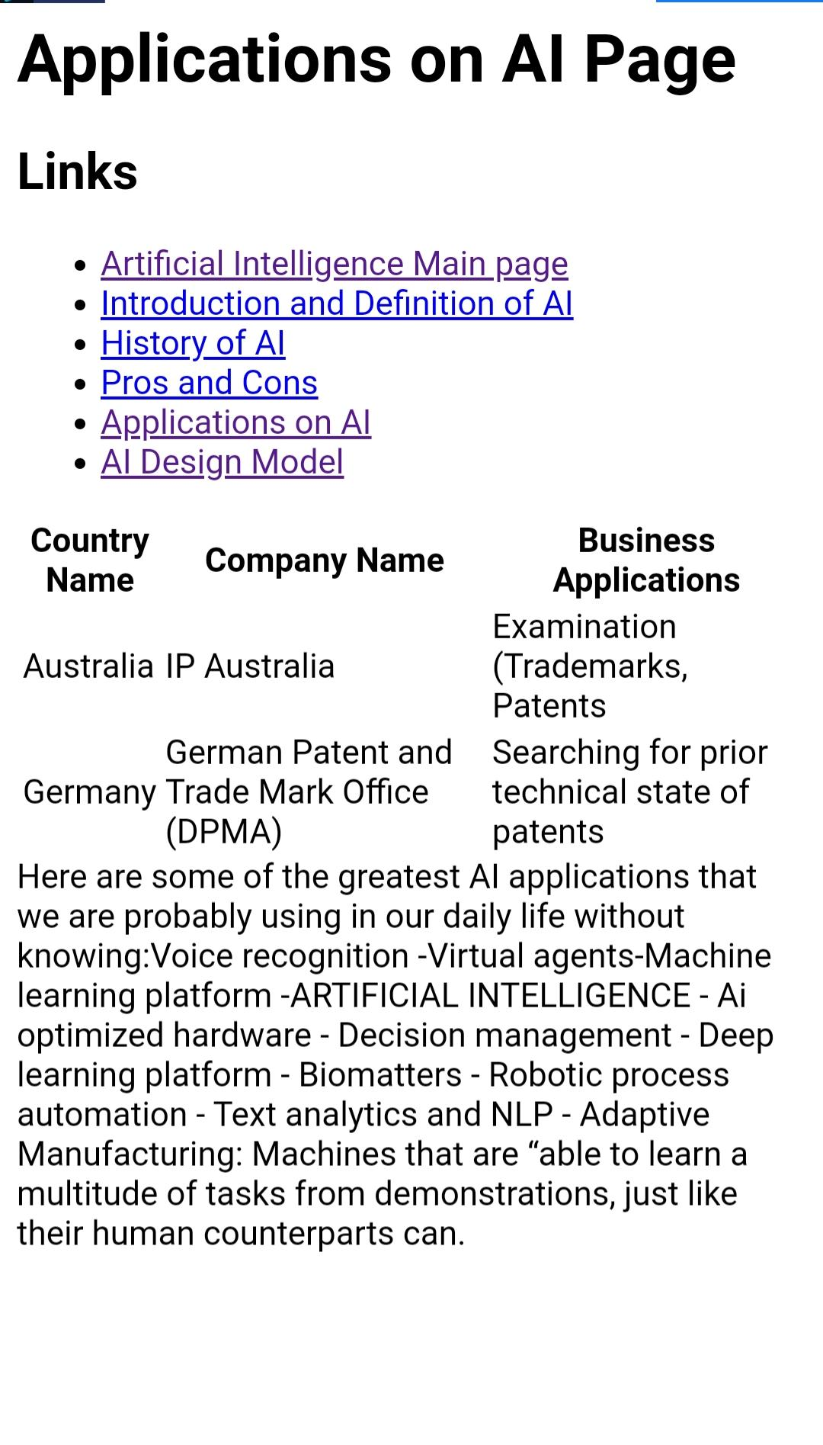
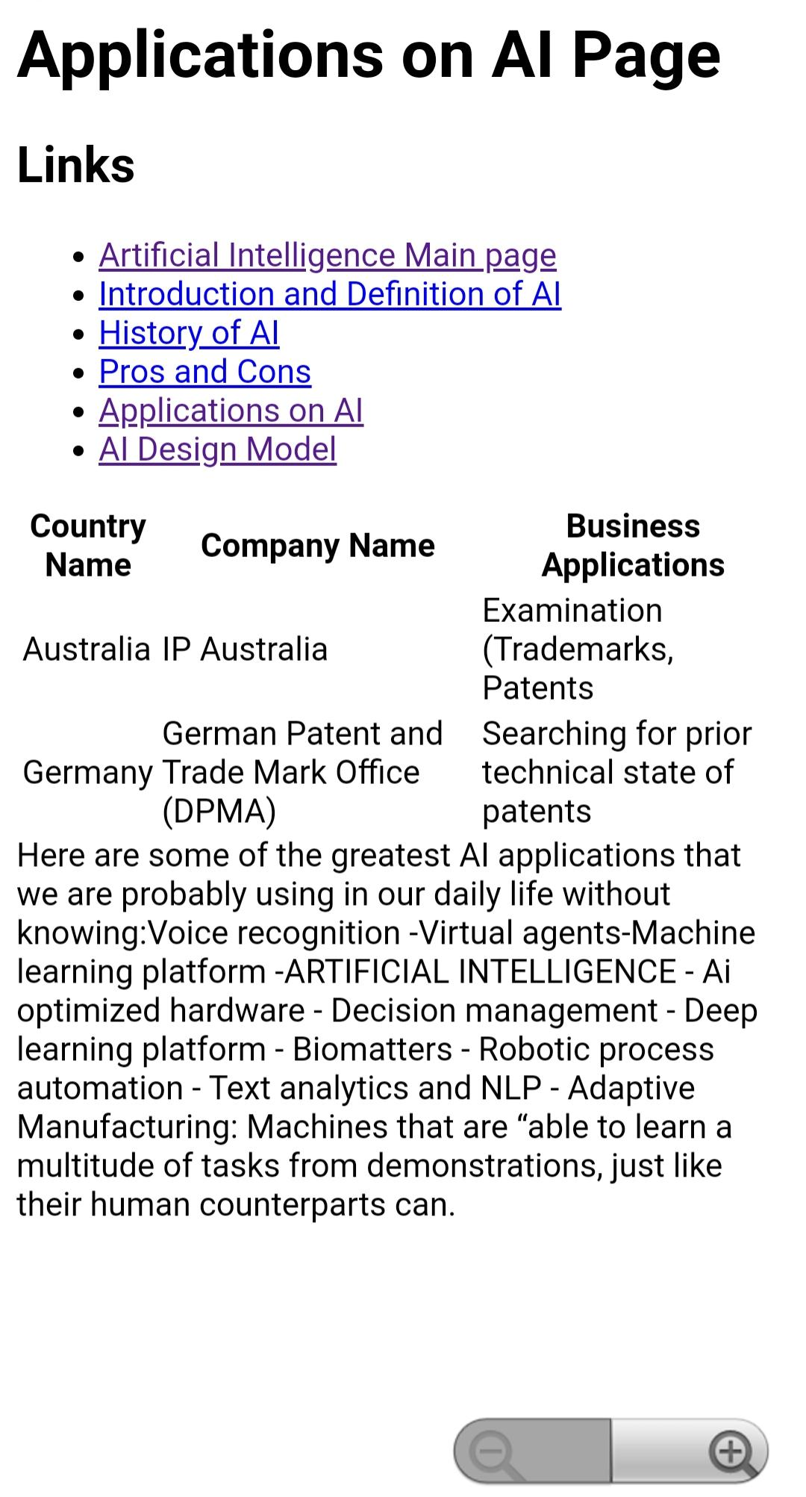
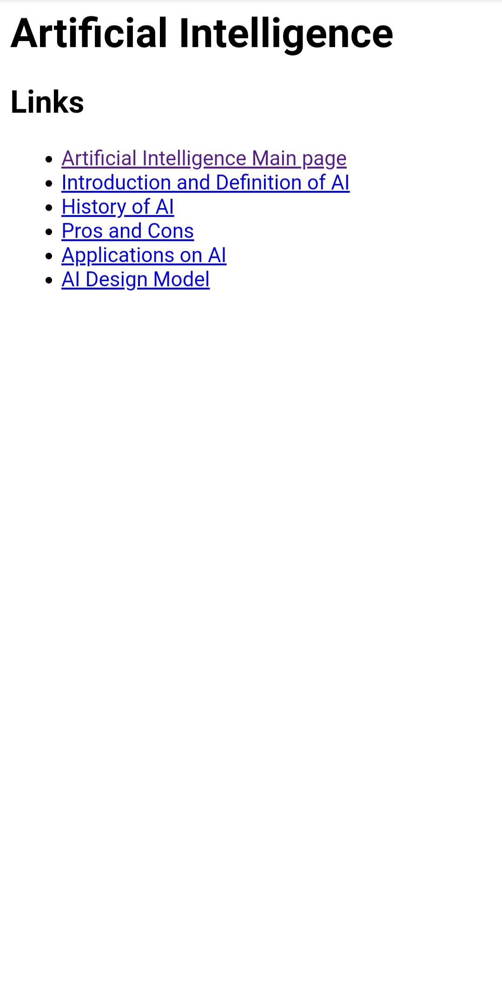
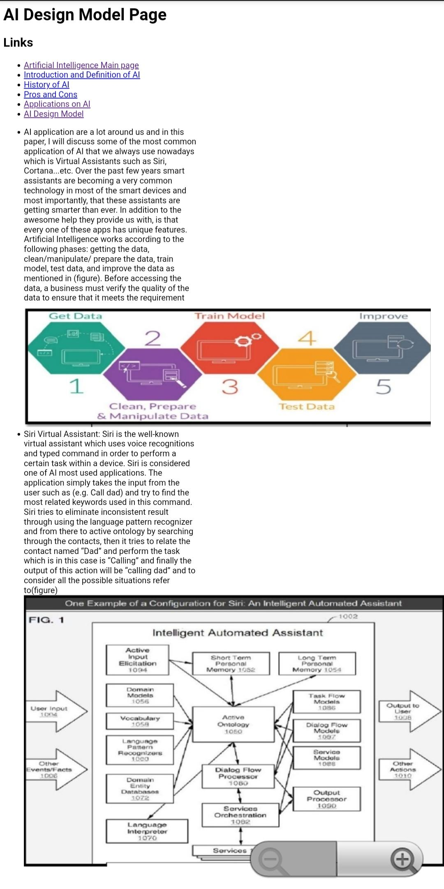
Source Code:

<html>

<body>
<h1>Artificial Intelligence </h1>

<h2>Links</h2>
<ul>
<li><a href=”hishamproject.html”>Artificial Intelligence Main page</a>
</li>
<li><a href=”introductionanddefinitionofai.html “>Introduction and Definition of AI </a>
</li>
<li><a href=”historyofai.html”>History of AI</a>
</li>
<li><a href=”prosandcons.html”>Pros and Cons</a>
</li>
<li><a href=”applicationsonai.html”>Applications on AI</a>
</li>
<li><a href=”aidesignmodel.html”>AI Design Model</a>
</li>
</ul>
</body>

</html>

